**Q1.** **Create a java program to print your mother and father name, age, salary, phone number, address like city state country.**

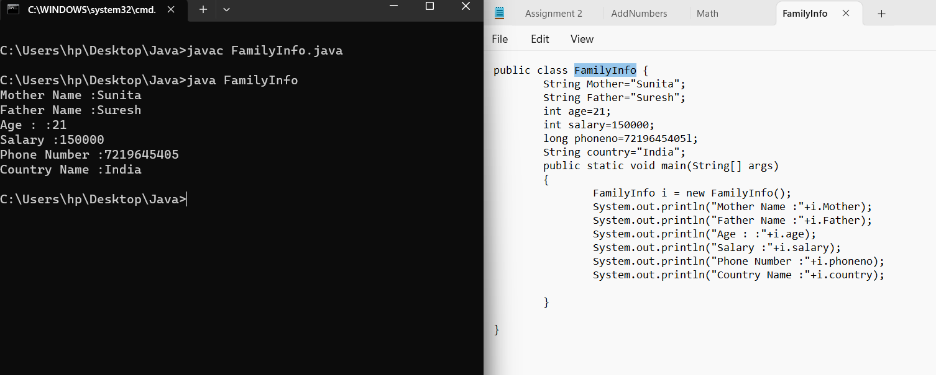

**Q2.** **Write a java program to print the below msg in the given format**

**hello**

**welcome to**

**edubridge online classes.**

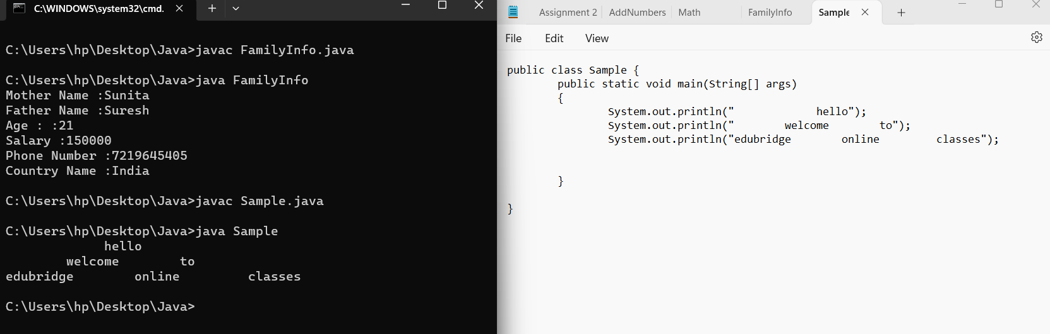

**Q3.What is default package in java.**

In Java, there is no concept of a "default package" in the same way there are packages with explicit names. The default package refers to classes that are not explicitly placed in a named package. When you don't specify a package for a class, it is placed in the default package. This means the class is in the default package and not in any named package. The default package is not recommended for larger projects because it can lead to naming conflicts and issues with code organization.

**Q4.List the types of datatypes with size and give an example of each by doing declaring and initializating the variables.**

|  |  |  |
| --- | --- | --- |
| **Data Type** | **Size** | **Default value** |
| Byte | 1 | 0 |
| Short | 2 | 0 |
| Int | 4 | 0 |
| Long | 8 | 0 |
| Flot | 4 | 0.0 |
| Double | 8 | 0.0 |
| Char | 2 | Empty |
| Boolean | 1 | False |

Byte:  
 byte a = 32;

Short:

short b = 1000;

Integer:

int c = 5;

Long:

long d = 123456789L;

Flot:

float e= 3.14f;

Double:

double f = 3.14159265359;

Char:

char g= 'A';

Boolean:

boolean h = true;

**Q5.** **Write a program to display the names of your friends by calling the static methods**

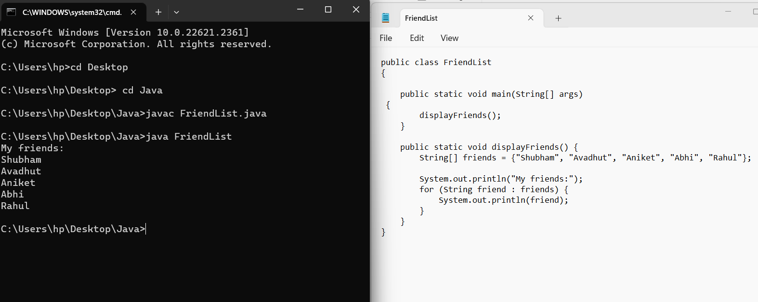

**Q6**.**Write a program to add two number by using static method**

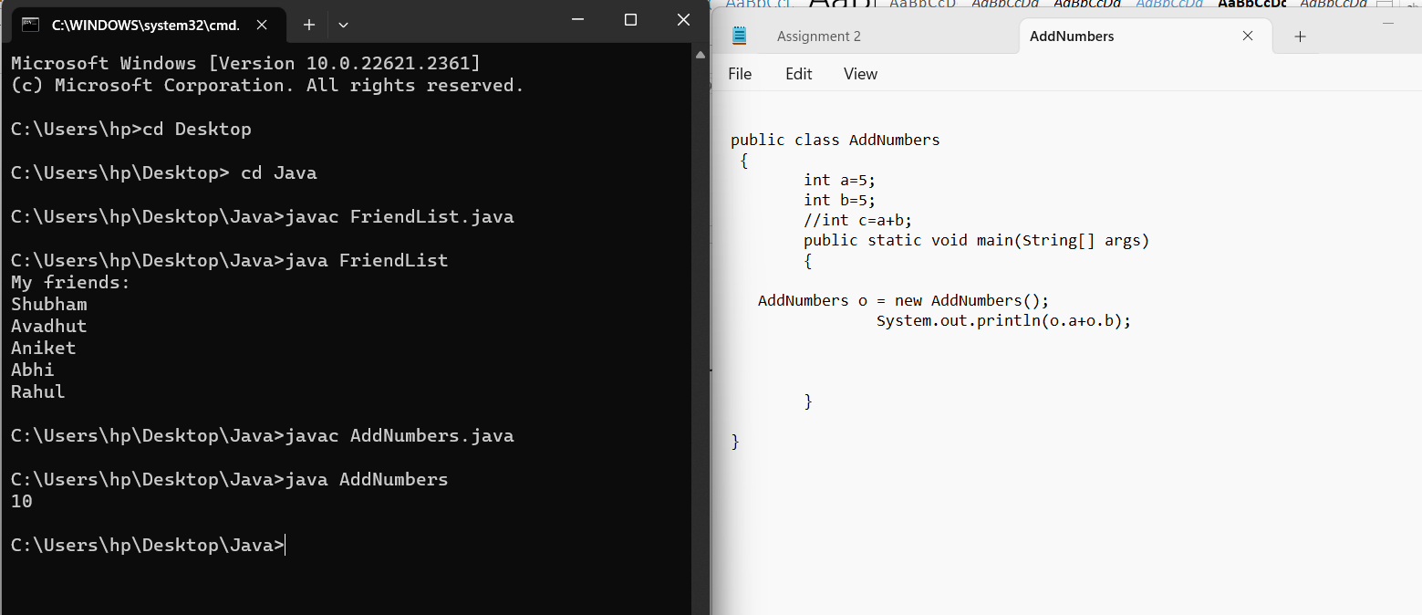

**Q7.** **What are the rules of naming the java file.**

1. Java file names must be unique.
2. Java file names must start with a letter.
3. Java file names can contain only letters, numbers, and underscores.
4. Java file names should be descriptive of the class or interface they contain.
5. Java file names should be short and easy to remember**.**

**Q8.** **What are the rules of naming the class**

1. Use mixed case with the first letter of each internal word capitalized
2. Keep class names simple and descriptive
3. Use whole words and avoid acronyms and abbreviations
4. Make names as long as necessary

**Q9. What are the rules for naming the methods**

1. Start with a lowercase letter
2. Use uppercase letters for any other words in the name
3. Not have any spaces

**Q10. What are the rules for naming variables in java**

1. Variable names should be descriptive and easy to read.
2. Variable names should be short but meaningful.
3. Variable names should start with a lowercase letter.
4. Variable names should be camelCase-cased, meaning that each new word starts with an uppercase letter.
5. Variable names should not contain spaces or special characters, such as underscores or dollar signs.
6. Variable names should not be the same as keywords or built-in methods in Java**.**

**Q11.** **Which is the main entry point of java program**

The main entry point of a Java program is the main() method. It is a special method that is required in every Java application, and it is the method that the Java Virtual Machine (JVM) calls to begin the execution of the program. The main() method must be declared as public static void main(String[] args). It can contain any code that you want to be executed when the program starts.

**Q12. Who is invoking the main method of java**

The Java Virtual Machine (JVM) invokes the main method of a Java program. When the JVM starts up, it looks for a class with a main method that is declared as public, static, and returns void. The JVM then calls this method to start the program.

The main method is usually used to initialize the program and to start executing other methods. It can also be used to handle command-line arguments.

**Q13. Why main has to be static method**

The main() method in Java must be static so that the JVM can call it without creating an instance of the class that contains the main() function. When the Java runtime starts, there is no class object. If the main method is not static, the JVM will be unable to call it.

The static keyword is used to define the main() method as static. Static methods are the only methods in Java that can be called using the class name. The static keyword is an access modifier that is used for memory management. It can be used with various variables, methods, blocks, and nested classes. If any of these are missing, the Java program will compile but a runtime error will be thrown.

**Q14 .components of java program are**

1. Classes: are the blueprints for objects. They define the object's properties and methods.
2. Variables: are containers for data. They can store numbers, strings, objects, and other types of data.
3. Statements: are instructions that the Java compiler executes. They can be used to assign values to variables, control the flow of execution, and call methods.
4. Methods: are actions that objects can perform. They can take input, perform calculations, and return output.
5. Packages: are groups of classes that are related to each other. They are used to organize code and make it easier to find the classes you need.
6. Imports: are statements that allow you to use classes from other packages in your code.
7. Comments: are lines of code that the Java compiler ignores. They are used to add explanatory text to your code.

**Q15. In which area .class is stored**

Class definitions are stored in the method area. The method area is a separate area that is neither the stack nor the heap. The class loader reads the “.class” file, generates the corresponding binary data, and saves it in the method area.

**Q16. In which area object are stored**

Objects are typically stored in the heap area of a JVM. the heap is a region of memory that is allocated dynamically, and it can grow or shrink depending on the needs of the application. Objects are stored in the heap because they can be of any size or type, and the heap allows the JVM to manage the memory efficiently.

**Q17. Why do we call as java simple**

Java is considered a simple programming language for a variety of reasons. First, its syntax is based on C and C++, so programmers who are already familiar with these languages will find it easy to learn Java. Second, Java has a relatively small number of keywords, which makes it easier to remember and use. Third, Java code is very readable, even to people who are not familiar with the language. This is because Java code is structured in a way that is similar to English, with statements separated by semicolons and blocks of code indented. Finally, Java has a large and active community of developers who are always willing to help beginners. This makes it easy to get help if you get stuck while learning Java.

**Q18. Write a program to sub, division and multiplication by using static method, pass the arguments and return the result to main method and print the result.**

